### Miniature House #3 - Cape Cod with Dormers

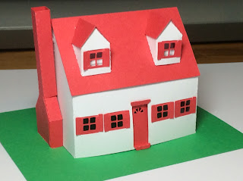

This miniature house is exactly the same as the Cape Cod. The added feature is two dormers to the front of the house and a different design on the front door. I added a scrap of white paper to the inside of the dormer to reflect light since the roof was red.  
  
I used card stock.